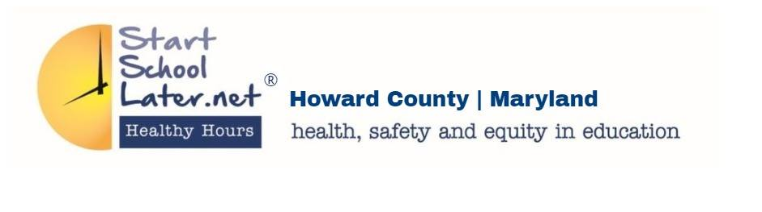
BOE Election Candidate School Hours Questionnaire
Please return to: sslhoco@gmail.com

Candidate Name: __________________________________ District: ________

1. Will you sign Start School Later’s 2013 petition at https://sign.moveon.org/petitions/changing-howard-county? If you won’t sign it, please explain why.

2. Based on the research that later middle and high school start times increase graduation rates and decrease absenteeism, with disadvantaged students benefiting the most from age-appropriate school hours, do you feel the current school hours affects the County’s ability to be a leader in K-12 education for all students?

3. What hours would you define as healthy, safe, and age appropriate? The current school hours are: Elementary 8:15-9:25 a.m. start times, Middle School 7:40-8:25 a.m. start times, and High School 7:25 a.m. start time.
Elementary School:
Middle School:
High School:
4. On December 19, 2017, Staff proposed four models for bell times that could be implemented. All four models had Elementary starting between at 8:30 a.m. and 9:30 a.m. and Middle between 8:00 a.m. and 8:45 a.m. Model 1: High school at 8 a.m. Model 2: High School at 8:15 a.m. Model 3: High School at 8:30 a.m. Model 4: High School at 8:45 a.m. What do you think about these four proposed models?

5. With the Board of Education purchasing a new bus routing system for the Department of Transportation, what would be your timeline of implementation healthy school hours?

6. Currently, HCPSS services 5 parochial schools with 21 bus routes dedicated to those schools at a price tag of $800,000 annually to HCPSS. The HCPSS Transportation department uses their manpower to design and maintain those routes. The BOE’s Legal Counsel stated that the school system is not legally required to supply bus service if a student does not reside on a public school bus route. What are your thoughts about HCPSS providing this extra service to these parochial schools?

7. In your prior experience and positions, what have you done to ensure all Howard County Public School students (K-12) have healthy, safe, and age appropriate school hours?

8. In your elected position, what will you do to ensure healthy and safe school hours for all of Howard County Public School Students? Please be specific: Resolutions, recommendations, funding requests, educational outreach, implementation efforts, etc.

9. Is there anything else you would like your constituents and future voters to know about your position on safe, healthy, and age-appropriate school hours?

