Start School Later, Inc. - Press Kit

History of Start School Later, Inc:
Start School Later, Inc. was co-founded in 2011 by Maribel Cabrera Ibrahim and Terra Ziporyn Snider - two Maryland women familiar with the research and who wanted to enact positive change. Start School Later was incorporated in Maryland as a non-profit, and obtained national 501(c)(3) status in 2014. Ms. Ibrahim currently serves as Operations Director and Dr. Snider serves as Executive Director.

Mission:
Start School Later is a coalition of health professionals, sleep scientists, educators, parents, students, and other concerned citizens dedicated to increasing public awareness about the relationship between sleep and school hours and to ensuring school start times compatible with health, safety, education, and equity.

Boilerplate:
Start School Later is a 501(c)(3) nonprofit organization working to ensure school start times compatible with health, safety, education, and equity. Visit their website at: www.startschoollater.net.

About Start School Later management and partnerships:
Start School Later is fully managed by volunteers, with operational costs covered by donations, grants, and local chapter fees. Many of our national and local volunteers are parents who serve in the health, mental health, or educational fields. All of our national and local volunteers are highly dedicated and passionate about improving the health and safety of teens, including several high school students who lead local chapters. Leadership bios can be found on the National Management Team section of our site. A list of our coalition partners can also be found on our site.

Chapter Count:
Start School Later has local grassroots chapters scattered around the country, with new chapters continuously being formed. For example, in January of 2016 there were 45 chapters of Start School Later and in January of 2017 there were 87 chapters; in January of 2020 there were 125 chapters. The most recent count can be found on the Local Chapters section of our website.

Why is sleep so important?
Sleep is essential for growth, development, physical wellness, emotional well-being, and learning. Sleep experts have found that it is not just the quantity of sleep that counts, but also the consistency, timing, and quality of that sleep. Adolescents require 8.5 to 9.5 hours of sleep for optimum health. Teens with deficient sleep are at increased risk for car crashes, substance use, obesity and diabetes, sports injuries, depression, suicide, school-based violence, and more. A compilation of the research can be found on our site.

What happens to sleep during puberty that warrants later school start times?
Today, many middle and high schools start class in the 7 o’clock hour or even earlier, a practice that makes it virtually impossible for teens to get the sleep that their growing brains and bodies need. The problem stems from two biologic changes at adolescence: 1) a shift in the body's internal clock in which the sleep hormone melatonin is secreted later in the evening than in younger children and older adults; and 2) an increased ability to resist the pressure to fall asleep due to an elongation of the "sleep drive". These changes make it difficult for most teenagers to fall asleep before about 11 p.m. or to naturally wake before about 8 a.m. Requiring students to rise at 5 or 6 a.m. to catch a school bus or drive to school means they end up getting no more than six or seven hours of sleep and have critical stages of sleep disrupted, even if they have early bedtimes imposed upon them. Schools with later bell times not only allow more students to get healthy sleep but have happier students and families, better attendance and graduation rates, less depression and stimulant use, and even lower car crash rates.

How big is the problem?
Study after study has confirmed that American teenagers are not getting healthy sleep. Today nearly two-thirds of U.S. high school students are getting under eight hours of sleep on school nights, and two-fifths are getting under six hours of sleep. While other factors such as scheduling overload and electronic use can influence teen sleep, it is recognized that intervening in early school start times is the “low hanging fruit” in improving adolescent sleep due to several reasons: 1) early school start times directly disrupt teen sleep regardless of bedtime; 2) early school start times impact entire communities; and 3) school day start times are within our control. The Centers for Disease Control and Prevention, the American Academy of Pediatrics, the American Medical Association, and other health groups recommend that middle and high schools start after 8: 30 a.m., but current estimates show that fewer than one in five middle and high schools comply with the recommendation.

How many schools have moved to later bell times?
This question is difficult if not impossible to answer. We know that hundreds of schools have adopted later start times in the last two decades – however there is no current comprehensive tracking at state or federal levels, and schools may change starting times for a variety of reasons. In addition, some schools make modest changes that are good, but not fully in accordance with expert recommendations. We do, however, try to maintain a sampling of schools who have made some modifications in the interest of student health, safety, and learning.
Why haven’t more schools changed?
Lack of awareness of the research is one of the biggest barriers to change, which is why all of us should be involved in raising the conversation at the local, state, and national levels. Myths and misconceptions also surround the issue.

For more information please feel free to explore our website: www.StartSchoolLater.net or contact our Communications Director Stacy Simera, LISW-S, SAP: stacy@startschoollater.net

Photos/Graphics:
The following pages include photos or graphics that are in the public domain and/or generated by Start School Later volunteers and can be freely used. We ask that you credit Start School Later, ideally with a link to www.startschoollater.net – unless otherwise specified.

0635 NE Ohio bus stop:

0630 Annapolis, MD bus stop:

0645 Bloomington, Indiana bus stop:

CA student with 7:15 start time:
Exhausted Maryland teen after school on couch:

Two high school students asleep in a class:

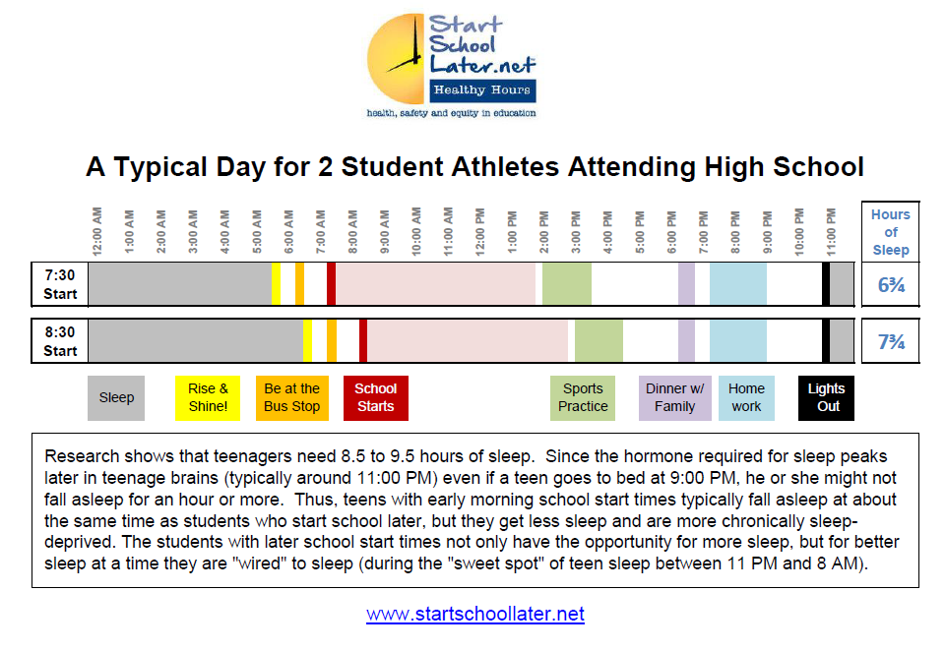
Ball and Chain Poster, Credit: Clayton Cavanaugh, Start School Later

“A Tale of Two Athletes” comparison:
Infographics:
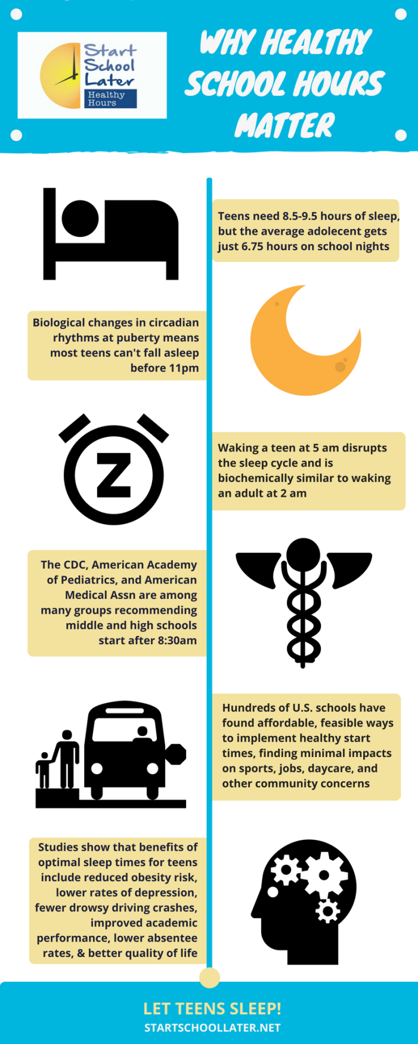
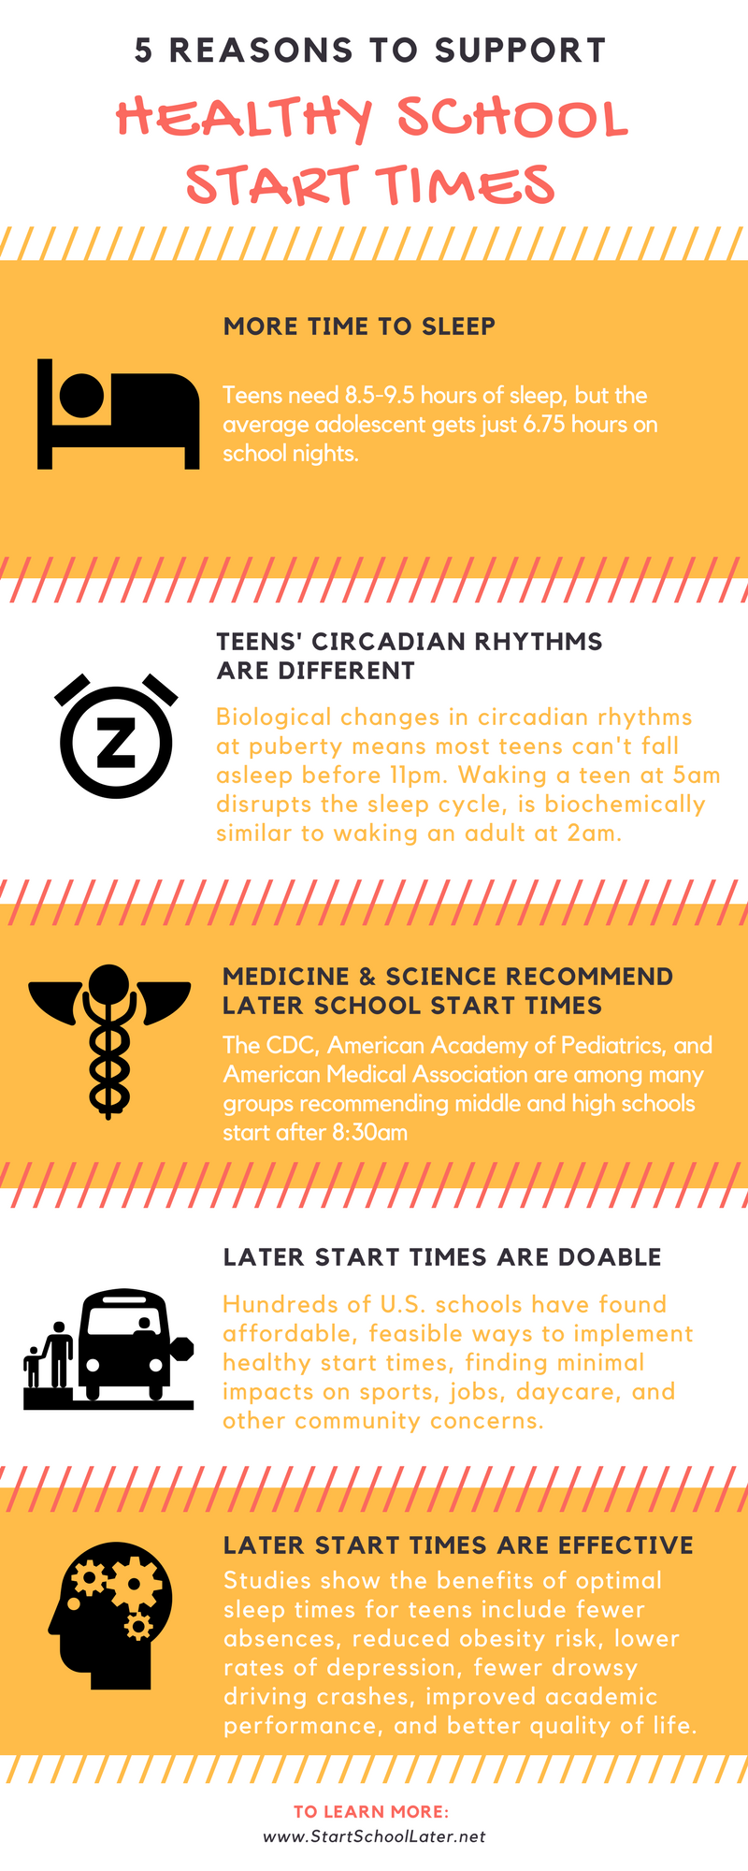

NE Ohio Bus Stop Comparisons, Same Day in April, 0635 and 0740:

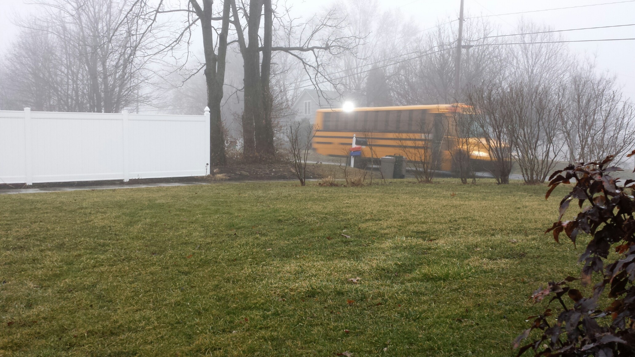

O600 Arlington, TN Bus Stop:
